**Software Requirements Specification**

**for**

**ImtiazGo.com**

Version 1.0 approved.

Prepared by 21F-9204, 21F-9142, 21F-9219, 21F-9054.

Buzz Inc.

17th March 2024

Table of Contents

Table of Contents ii

Revision History ii

1. Introduction 1

1.1 Purpose 1

1.2 Document Conventions 1

1.3 Intended Audience and Reading Suggestions 1

1.4 Product Scope 1

1.5 References 2

2. Overall Description 2

2.1 Product Perspective 3

2.2 Product Functions 3

2.3 User Classes and Characteristics 3

2.4 Operating Environment 3

2.5 Design and Implementation Constraints 4

2.6 User Documentation 5

2.7 Assumptions and Dependencies 6

3. External Interface Requirements 7

3.1 User Interfaces 8

3.2 Hardware Interfaces 8

3.3 Software Interfaces 9

3.4 Communications Interfaces 10

4. System Features 11

4.1 System Feature 1 **Error! Bookmark not defined.**

4.2 System Feature 2 (and so on) **Error! Bookmark not defined.**

5. Other Nonfunctional Requirements 15

5.1 Performance Requirements 15

5.2 Safety Requirements 15

5.3 Security Requirements 16

5.4 Software Quality Attributes 16

5.5 Business Rules 17

6. Other Requirements 18

Appendix A: Glossary 19

Appendix B: Analysis Models 20

Appendix C: To Be Determined List 21

Revision History

|  |  |  |  |
| --- | --- | --- | --- |
| **Name** | **Date** | **Reason For Changes** | **Version** |
|  |  |  |  |
|  |  |  |  |

# Introduction

## Purpose

The purpose of this Software Requirements Specification (SRS) document is to outline the requirements for the development and implementation of the Imtiaz Go project. This project aims to revolutionize the retail experience by eliminating checkout lines and streamlining the shopping process through innovative technology.

## Document Conventions

1. **Priority Assignment**: Each requirement statement is accompanied by its own priority level, indicating the importance or urgency of that specific requirement. Priority levels are categorized as High, Medium, or Low.
2. **Formatting**: Requirements are formatted consistently throughout the document to enhance readability and comprehension. Each requirement is numbered for easy reference and tracking.
3. **Language Usage**: Concise and clear language is employed to ensure that requirements are unambiguous and easily understandable by all stakeholders.
4. **Identification**: Requirements are uniquely identified using a prefix (e.g., REQ) followed by a sequential number to facilitate traceability and management.
5. **Terminology**: Technical terms and acronyms are defined in the glossary section to ensure clarity and consistency in communication.

## Intended Audience and Reading Suggestions

1. **Developers**: Individuals responsible for designing, coding, and testing the software components of the Imtiaz Go system. Developers will find detailed functional and non-functional requirements in this document to guide the implementation process.
2. **Project Managers**: Individuals overseeing the execution and progress of the Imtiaz Go project. Project managers can use this document to gain insight into the project scope, objectives, and specific requirements to effectively plan and manage project activities.
3. **Marketing Staff**: Individuals responsible for promoting and communicating the features and benefits of the Imtiaz Go system to potential customers. Marketing staff can refer to this document to understand the key functionalities and user interface aspects of the system for accurate marketing messaging.
4. **Users**: Customers who will interact with the Imtiaz Go system while shopping at Imtiaz Go stores. While users may not directly engage with the SRS document, they will indirectly benefit from its contents by experiencing a seamless and efficient shopping experience.
5. **Testers**: Individuals responsible for verifying and validating the functionality and performance of the Imtiaz Go system. Testers will find detailed requirements and acceptance criteria in this document to ensure comprehensive test coverage.
6. **Documentation Writers**: Individuals tasked with creating user manuals, technical documentation, and training materials for the Imtiaz Go system. Documentation writers can use this document as a reference to accurately document system features and functionalities.

The rest of this SRS document is organized as follows:

* **Introduction**: Provides an overview of the Imtiaz Go project, its purpose, and the scope covered by this document.
* **Overall Description**: Describes the context and origin of the project, product functions, user classes, operating environment, design constraints, and other relevant information.
* **External Interface Requirements**: Specifies the requirements for user interfaces, hardware interfaces, software interfaces, and communications interfaces.
* **System Features**: Details the functional requirements of the Imtiaz Go system, including item tracking, transaction processing, integration with Amazon, and user interface.
* **Other Nonfunctional Requirements**: Outlines performance, safety, security, and software quality attributes requirements.
* **Other Requirements**: Covers any additional requirements not addressed in previous sections.
* **Appendices**: Include glossary, analysis models, and a to-be-determined list for reference.

## Product Scope

Imtiaz Go is designed to streamline the shopping process by eliminating checkout lines and simplifying payment procedures for customers.

**Purpose:**

The primary purpose of Imtiaz Go is to enhance customer convenience and satisfaction by leveraging advanced technology to automate and expedite the checkout process. By incorporating special cameras and computer vision algorithms, Imtiaz Go allows customers to pick up desired items from the store shelves and seamlessly complete their purchases without the need for manual scanning or waiting in queues.

**Relevant Benefits:**

* **Timesaving**: Customers can enjoy a quicker shopping experience without the hassle of waiting in long checkout lines.
* **Convenience**: With automated payment processing, customers can avoid the need to handle cash or cards, enhancing overall convenience.
* **Efficiency**: Imtiaz Go enhances operational efficiency for retail stores by reducing checkout processing times and optimizing staff resources.

Objectives and Goals:

* **Customer Satisfaction**: Imtiaz Go aims to enhance customer satisfaction by providing a smooth and hassle-free shopping experience.
* **Operational Efficiency**: The system aims to improve operational efficiency for retail stores by streamlining checkout processes and reducing transaction times.
* **Market Differentiation**: By offering a cutting-edge, technology-driven shopping experience, Imtiaz Go seeks to differentiate itself in the market and attract customers seeking convenience and innovation.

**Alignment with Corporate Goals:**

The Imtiaz Go project aligns with corporate goals and business strategies aimed at enhancing customer experience, improving operational efficiency, and staying competitive in the retail industry. By investing in innovative technologies such as Imtiaz Go, the company aims to strengthen its market position and drive growth by meeting evolving customer demands and preferences.

## References

1. **Imtiaz Go Vision and Scope Document**

* Author: [Imtiaz Retail Group]
* Version: 1.0

1. **Imtiaz Go User Interface Style Guide**

* Author: [Imtiaz Retail Group Design Team]
* Version: 1.0

1. **Imtiaz Go System Requirements Specification**

* Author: [Imtiaz Retail Group Development Team]
* Version: 1.0

1. **Imtiaz Go Use Case Document**

* Author: [Imtiaz Retail Group Business Analysts]
* Version: 1.0

# Overall Description

## Product Perspective

The Imtiaz Go system is a standalone retail solution designed to operate within retail stores. It interacts with customers, tracking selected items and processing transactions seamlessly.

**Context and Origin:**

Imtiaz Go originated from the need to enhance the traditional shopping experience by addressing common pain points such as long checkout lines and cumbersome payment procedures. The system was conceptualized to leverage advanced technology, including special cameras and computer vision algorithms, to automate the checkout process and improve overall customer satisfaction.

**Relationship to Larger System:**

While Imtiaz Go is a self-contained product, it may interact with other systems within the retail environment, such as inventory management systems and customer relationship management (CRM) systems. However, the focus of this SRS is on defining the requirements specific to the Imtiaz Go system itself, including its functionalities, interfaces, and performance criteria.

**Diagram:**

A simple diagram illustrating the major components of the Imtiaz Go system and any relevant interfaces with external systems would be beneficial for visualizing the product perspective. However, as the Imtiaz Go system is self-contained, with no direct dependencies on other systems, the diagram may primarily highlight internal components and their interactions.

## Product Functions

* **Automated Item Tracking**: The system automatically tracks items selected by the user using special cameras and computer vision technology.
* **Seamless Checkout Process**: Users can complete their purchases without waiting in checkout lines or manually scanning items.
* **Integration with Amazon**: The system seamlessly integrates with Amazon's payment gateway for automated transaction processing.
* **Real-time Transaction Summary**: Users receive real-time transaction summaries displaying selected items and total costs.
* **User Interface**: Intuitive user interface provides a seamless and convenient shopping experience.

## User Classes and Characteristics

User classes include customers and store employees. Customers may vary in technical expertise, while store employees require administrative access to the system.

1. **Regular Shoppers:**

* **Characteristics:** These users are frequent shoppers who visit retail stores for routine purchases.
* **Requirements:** They require a seamless and efficient checkout process to save time and effort.

1. **Occasional Shoppers:**

* **Characteristics:** These users visit retail stores occasionally for specific items or needs.
* **Requirements:** They may require more guidance and assistance in using the Imtiaz Go system due to less frequent usage.

1. **Technical Users (e.g., Store Staff):**

* **Characteristics:** These users have technical expertise and are responsible for managing and maintaining the Imtiaz Go system within the store.
* **Requirements:** They require access to administrative functions and technical support to ensure smooth operation of the system.

1. **Elderly or Technically Challenged Users:**

* **Characteristics:** These users may have limited technical proficiency or physical mobility.
* **Requirements:** They require a user-friendly interface with clear instructions and minimal complexity to facilitate ease of use.

1. **Security Personnel:**

* **Characteristics:** These users are responsible for monitoring the security of the retail store.
* **Requirements:** They may require access to security features within the Imtiaz Go system to ensure compliance with store policies and regulations.

1. **Administrators:**

* **Characteristics:** These users have administrative privileges and are responsible for system configuration and management.
* **Requirements:** They require access to advanced settings and functionalities for system configuration and troubleshooting.

Among these user classes, regular shoppers and occasional shoppers are considered the most important to satisfy, as they represent the primary user base of the Imtiaz Go system. Their satisfaction and ease of use are paramount to the success of the product.

## Operating Environment

The system will operate within retail stores, requiring compatible hardware and network infrastructure.

1. **Hardware Platform:**

* Special cameras and sensors are installed throughout the store to track items selected by users.
* Point-of-sale (POS) terminals or devices equipped with necessary hardware components for transaction processing.

1. **Operating System and Versions:**

* The Imtiaz Go software is compatible with various operating systems commonly used in retail environments, including but not limited to:
* Windows 10
* Linux (Ubuntu, CentOS)
* Android
* iOS

1. **Other Software Components or Applications:**

* Integration with Amazon's payment gateway for transaction processing.
* Compatibility with Imtiaz Retail Group's existing systems, such as inventory management and CRM systems, for seamless data exchange and operations.

1. **Networking Infrastructure:**

* Reliable and secure network connectivity to facilitate communication between Imtiaz Go devices, backend servers, and external systems.
* Wi-Fi or Ethernet connectivity to ensure real-time data transmission and synchronization.

1. **Environmental Conditions:**

* The operating environment may include varying environmental conditions typical of retail stores, such as temperature fluctuations, ambient lighting, and noise levels.
* The Imtiaz Go hardware components must be capable of withstanding these environmental factors to ensure uninterrupted operation.

1. **Compliance and Regulations:**

* Compliance with relevant industry standards and regulations governing retail operations and data security.
* Adherence to Imtiaz Retail Group's internal policies and procedures regarding software deployment and usage.

## Design and Implementation Constraints

Constraints may include hardware compatibility, data security regulations, and integration with existing Amazon systems.

1. **Regulatory Compliance:**

* Adherence to regulatory policies and standards governing retail operations, data privacy, and payment processing. Developers must ensure that the Imtiaz Go system complies with relevant regulations to mitigate legal risks.

1. **Hardware Limitations:**

* Hardware limitations such as processing power, memory constraints, and compatibility with existing infrastructure may impact system design and functionality. Developers must optimize resource usage to ensure efficient operation on designated hardware platforms.

1. **Interfaces to Other Applications:**

* Integration with external systems, such as Amazon's payment gateway and Imtiaz Retail Group's inventory management system, requires adherence to specified protocols and data exchange formats. Developers must implement robust interfaces to facilitate seamless communication between Imtiaz Go and external applications.

1. **Technology and Tools:**

* Specific technologies, tools, and frameworks may be mandated or preferred for development by Imtiaz Retail Group. Developers must use approved technologies and tools to ensure compatibility, supportability, and maintainability of the Imtiaz Go system.

1. **Security Considerations:**

* Security is a critical aspect of the Imtiaz Go system, given its involvement in payment processing and handling of sensitive customer data. Developers must implement robust security measures, including encryption, authentication, and access controls, to protect against unauthorized access and data breaches.

1. **Design Conventions and Programming Standards:**

* Adherence to design conventions, programming standards, and best practices defined by Imtiaz Retail Group or industry standards is essential for ensuring code quality, readability, and maintainability. Developers must follow established guidelines to maintain consistency and facilitate collaboration within the development team.

1. **Language and Communication Protocols:**

* Language requirements and communication protocols must be standardized to ensure interoperability and compatibility across different components of the Imtiaz Go system. Developers must use agreed-upon languages and protocols for consistent communication and data exchange.

1. **Maintenance and Support:**

* The customer's organization may be responsible for maintaining and supporting the delivered software post-implementation. Developers must design the system with maintainability in mind, including clear documentation, modular architecture, and error-handling mechanisms, to facilitate ongoing support and updates.

## User Documentation

User documentation will include user manuals and on-screen instructions to guide customers through the shopping process.

1. **User Manual:**

* A detailed user manual will provide step-by-step instructions on how to use the Imtiaz Go system, including account setup, item selection, checkout process, and troubleshooting tips.

1. **Online Help:**

* Online help resources will be integrated into the Imtiaz Go software interface to provide context-sensitive assistance and guidance to users. Users can access relevant help topics and FAQs directly within the application.

1. **Tutorials:**

* Interactive tutorials and walkthroughs will be available to users to familiarize them with the features and functionalities of the Imtiaz Go system. Tutorials will cover common tasks, best practices, and tips for optimizing the user experience.

1. **FAQs (Frequently Asked Questions):**

* A compilation of frequently asked questions and answers will be provided to address common queries and concerns raised by users. FAQs will cover topics such as account management, payment processing, and system troubleshooting.

1. **Training Materials:**

* Training materials, including presentations and training videos, will be available for store staff and administrators to facilitate onboarding and training sessions. These materials will cover system setup, configuration, and maintenance procedures.

1. **Delivery Formats and Standards:**

* User documentation will be delivered in electronic format, accessible through the Imtiaz Go software interface and the company's internal documentation portal.
* Documentation will adhere to standard formatting and style guidelines to ensure consistency and readability.
* Documentation will be available in multiple languages to accommodate diverse user populations and enhance accessibility.

## Assumptions and Dependencies

Assumptions include the availability of stable network connectivity and cooperation from retail store management. Dependencies may include third-party APIs and software libraries.

1. **Availability of Required Hardware:**

* **Assumption:** The necessary hardware components, such as cameras, sensors, and POS terminals, will be available and compatible with the Imtiaz Go system.
* **Dependency:** The project timeline and functionality are contingent upon the timely procurement and deployment of required hardware.

1. **Integration with Third-Party Systems:**

* **Assumption:** Integration with external systems, such as Amazon's payment gateway and inventory management systems, will be feasible and adhere to specified protocols.
* **Dependency:** Successful integration with third-party systems is critical for seamless operation and transaction processing within the Imtiaz Go system.

1. **Compliance with Regulatory Requirements:**

* **Assumption:** The Imtiaz Go system will comply with relevant regulatory requirements and industry standards governing retail operations and data security.
* **Dependency:** Any changes in regulatory requirements or compliance standards may necessitate modifications to the system architecture and functionality, impacting project timelines and resources.

1. **Stable Operating Environment:**

* **Assumption:** The retail environment where the Imtiaz Go system will operate will maintain stability and consistency in terms of network connectivity, power supply, and environmental conditions.
* **Dependency:** Unforeseen disruptions or instabilities in the operating environment could affect the system's performance and reliability, requiring mitigation measures and adjustments.

1. **Availability of Skilled Personnel:**

* **Assumption:** Adequate skilled personnel, including developers, testers, and support staff, will be available to support the project throughout its lifecycle.
* **Dependency:** The availability of skilled personnel is crucial for the timely development, testing, and maintenance of the Imtiaz Go system. Shortages or turnover in personnel could impact project continuity and deliverables.

1. **Vendor Support and Maintenance:**

* **Assumption:** Vendors providing third-party components, software tools, or services required for the project will provide adequate support and maintenance.
* **Dependency:** Dependence on vendor support ensures timely resolution of issues, updates, and patches, minimizing disruptions to project progress and system operation.

# External Interface Requirements

## User Interfaces

The user interface will be intuitive and easy to navigate, displaying selected items and transaction details.

1. **Customer-Facing Interface:**

* **Interface Components:** The customer-facing interface includes:
  + Item selection screen: Displays available products with relevant information such as price, description, and availability.
  + Transaction summary screen: Provides a summary of selected items and total cost before checkout.
  + Checkout screen: Allows users to complete their purchases and initiate payment processing.
* **GUI Standards:** The user interface follows modern GUI design principles, including:
  + Consistent layout and color scheme for enhanced usability.
  + Clear and intuitive navigation elements (buttons, menus) to facilitate user interaction.
  + Visual feedback (animations, transitions) to indicate user actions and system responses.
* **Screen Layout Constraints:** The layout of screens is optimized for different device form factors, including handheld POS devices and larger displays at checkout counters.
* **Standard Buttons and Functions: Standard** buttons and functions such as "Add to Cart," "Checkout," "Cancel," and "Help" are available across screens for consistent user interaction.
* **Keyboard Shortcuts:** Keyboard shortcuts may be available for common actions to enhance user efficiency and accessibility.
* **Error Message Display Standards:** Error messages are displayed clearly and concisely, indicating the nature of the error, and suggesting possible solutions.

1. **Store Staff/Administrator Interface:**

* **Interface Components: The staff/administrator interface includes:**
  + Administrative dashboard: Provides access to system configuration settings, transaction logs, and reporting tools.
  + Inventory management interface: Allows staff to monitor and manage product inventory levels in real time.
  + User management interface: Enables administrators to manage user accounts, permissions, and access levels.
* **GUI Standards:** The interface for store staff/administrators adheres to similar GUI standards as the customer-facing interface, with additional features tailored to administrative tasks.
* **Screen Layout Constraints:** The layout is designed to accommodate complex data displays and interactive controls required for administrative functions.
* **Standard Buttons and Functions:** Similar standard buttons and functions as the customer-facing interface are available, with additional administrative functionalities.
* **Error Message Display Standards:** Error messages are displayed with detailed information and instructions for resolving issues, considering the technical expertise of staff/administrators.

## Hardware Interfaces

The system will interface with special cameras and computers installed within retail stores to track items.

1. **Cameras and Sensors:**

* **Supported Device Types:** High-resolution cameras and sensors are installed throughout the store premises to track customer movements and item selections.
* **Data and Control Interactions:** Cameras and sensors capture visual and environmental data, including customer actions, item identification, and proximity detection.
* **Communication Protocols:** Data from cameras and sensors are transmitted to the software system using standardized communication protocols such as USB, Ethernet, or Wi-Fi.

1. **Point-of-Sale (POS) Terminals:**

* **Supported Device Types:** Handheld POS devices or fixed POS terminals are used by store staff at checkout counters.
* **Data and Control Interactions:** POS terminals interact with the software system to display transaction details, process payments, and update inventory records in real time.
* **Communication Protocols:** POS terminals communicate with the software system via wired or wireless connections, utilizing industry-standard protocols such as TCP/IP or serial communication.

1. **Network Infrastructure:**

* **Supported Device Types:** Routers, switches, and access points comprise the network infrastructure within the store premises.
* **Data and Control Interactions:** Network devices facilitate data transmission between various components of the Imtiaz Go system, including cameras, sensors, POS terminals, and backend servers.
* **Communication Protocols:** Network devices utilize standard networking protocols such as Ethernet, Wi-Fi, and TCP/IP for data communication and routing.

1. **Backend Servers:**

* **Supported Device Types:** Physical or virtual servers host the backend software components of the Imtiaz Go system, including databases, application servers, and payment gateways.
* **Data and Control Interactions:** Backend servers store and process transaction data, manage user accounts, and coordinate communication between frontend and backend components.
* **Communication Protocols:** Backend servers communicate with frontend components and external systems using APIs, web services, or proprietary protocols over secure connections.

1. **Payment Processing Devices:**

* **Supported Device Types:** Payment terminals or card readers are used to process payments from customers.
* **Data and Control Interactions:** Payment processing devices interact with the software system to authorize transactions, verify payment credentials, and update financial records.
* **Communication Protocols:** Payment terminals typically utilize secure communication protocols such as EMV, NFC, or PCI DSS-compliant protocols for transmitting payment data securely to the payment gateway.

## Software Interfaces

Integration with Amazon's payment gateway and technology will be essential for transaction processing.

1. **Database Management System (DBMS):**

* **Software Component:** MySQL version 8.0
* **Purpose:** The DBMS stores and manages data related to product inventory, customer accounts, transactions, and system configurations.
* **Data Items:** Product details (name, price, quantity), user accounts (credentials, purchase history), transaction records (items purchased, payment details), system settings (store configurations, user permissions).
* **Communication:** The Imtiaz Go system interacts with the MySQL database using structured query language (SQL) queries executed through JDBC (Java Database Connectivity) for database access.

1. **Operating System:**

* **Software Component:** Linux Ubuntu 20.04 LTS
* **Purpose:** The operating system provides the underlying platform for hosting and running the Imtiaz Go software components.
* **Communication:** The Imtiaz Go application is deployed and executed on Linux-based servers, utilizing system-level APIs and services provided by the operating system for process management, file I/O, and network communication.

1. **Payment Gateway Integration:**

* **Software Component:** Stripe API version 2021-03-23
* **Purpose:** The payment gateway integration allows customers to securely process payments using various payment methods, including credit/debit cards and digital wallets.
* **Data Items:** Payment details (card information, transaction amount, billing address), authorization responses, and transaction status updates.
* **Communication:** The Imtiaz Go system communicates with the Stripe API over HTTPS (Hypertext Transfer Protocol Secure) using RESTful web services, exchanging JSON (JavaScript Object Notation) formatted data for payment processing and transaction management.

1. **Third-Party Inventory Management System:**

* **Software Component:** SAP ERP version 10.0
* **Purpose:** Integration with the inventory management system enables real-time synchronization of product inventory levels and updates across the Imtiaz Go system.
* **Data Items:** Product inventory levels, stock keeping unit (SKU) information, product availability status.
* **Communication:** The Imtiaz Go system communicates with the SAP ERP system using SOAP (Simple Object Access Protocol) web services or OData (Open Data Protocol) APIs, exchanging XML (Extensible Markup Language) or JSON data for inventory management operations.

1. **Backend Application Server:**

* **Software Component:** Apache Tomcat version 9.0
* **Purpose:** The backend application server hosts and serves the Imtiaz Go web application, handling user requests, business logic processing, and data retrieval.
* **Communication:** The frontend components of the Imtiaz Go system interact with the backend application server using HTTP (Hypertext Transfer Protocol) requests and responses, exchanging JSON or XML data payloads for user authentication, session management, and data retrieval operations.

1. **Logging and Monitoring Tools:**

* **Software Component:** Log4j version 2.14, Prometheus version 2.29, Grafana version 8.0
* **Purpose:** Logging and monitoring tools are utilized for tracking system activities, performance metrics, and error handling within the Imtiaz Go system.
* **Communication:** The Imtiaz Go application integrates with Log4j for logging application events and errors, while Prometheus and Grafana are used for collecting and visualizing system performance metrics via HTTP endpoints or APIs.

## Communications Interfaces

The system may require communication with external servers or APIs for data synchronization and processing.

1. **Network Server Communications Protocols:**

* **Communication Standards:** The Imtiaz Go system utilizes HTTP/HTTPS protocols for communication between client devices (e.g., smartphones, tablets) and backend servers.
* **Message Formatting:** Data exchanged between client devices and backend servers is formatted using JSON (JavaScript Object Notation) or XML (Extensible Markup Language) for structured data representation.
* **Security and Encryption:** Communication over HTTPS ensures data encryption and secure transmission, mitigating risks associated with data interception and unauthorized access.
* **Data Transfer Rates:** The system aims to maintain optimal data transfer rates to ensure responsive user experience, with considerations for network latency and bandwidth availability.
* **Synchronization Mechanisms:** Asynchronous communication patterns are employed for non-blocking interactions between client devices and backend servers, allowing concurrent processing of multiple requests and responses.

1. **Email Communication:**

* **Communication Standards:** Email communication within the Imtiaz Go system adheres to SMTP (Simple Mail Transfer Protocol) standards for sending transactional emails, notifications, and updates to users.
* **Message Formatting:** Email messages are formatted using HTML markup for enhanced visual presentation, with plaintext alternatives provided for compatibility with email clients that do not support HTML rendering.
* **Security and Encryption:** Emails containing sensitive information (e.g., order confirmations, account notifications) are encrypted during transmission and may include digital signatures for message integrity verification.
* **Data Transfer Rates:** Email delivery latency is monitored to ensure timely delivery of critical notifications, with mechanisms in place to handle email queue management and retries for failed delivery attempts.

1. **Web Browser Interfaces:**

* **Communication Standards:** Web browser interfaces utilize standard HTTP/HTTPS protocols for rendering web pages, submitting user inputs, and retrieving dynamic content from backend servers.
* **Message** Formatting: Web pages are rendered using HTML, CSS, and JavaScript technologies, with AJAX (Asynchronous JavaScript and XML) employed for asynchronous data retrieval and updates without requiring full page reloads.
* **Security and Encryption:** Secure communication over HTTPS ensures data confidentiality and integrity, with server-side authentication mechanisms (e.g., SSL/TLS certificates) validating the identity of the backend servers.
* **Data Transfer Rates:** Web pages are optimized for efficient data transfer and rendering performance, with considerations for minimizing page load times and optimizing resource caching to enhance user experience.

1. **Electronic Forms:**

* **Communication Standards:** Electronic forms submitted by users are transmitted to backend servers using HTTP POST requests, with form data encoded in URL parameters or as multipart form data.
* **Message Formatting:** Form data is encoded using standard MIME (Multipurpose Internet Mail Extensions) formats, with support for various input types (text fields, checkboxes, radio buttons, dropdown menus) and file uploads.
* **Security and Encryption**: Form submissions are encrypted during transmission over HTTPS connections, preventing eavesdropping and tampering of sensitive user data.
* **Data Transfer Rates:** Form submission latency is optimized to ensure responsive user feedback and efficient data processing on the server side, with validation checks performed to ensure data integrity and accuracy.

# System Features

## 4.1 Automated Checkout Process

## 4.1.1 Description and Priority

*The Automated Checkout Process feature enables users to seamlessly complete their shopping experience without the need for manual checkout. This feature is of* ***high priority*** *as it constitutes the core functionality of the Imtiaz Go system, providing significant convenience and time-saving benefits to users.*

## 4.1.2 Stimulus/Response Sequences

* ***Stimulus:*** *User completes shopping and exits the store.*
* ***Response:*** *The system detects items taken by the user and generates a summary of the selected products.*
* ***Stimulus: User confirms intention to purchase and exit.***
* ***Response:*** *The system calculates the total bill and charges the user's Amazon account.*
* ***Stimulus:*** *The user encounters an error during the checkout process.*
* ***Response:*** *The system provides error feedback and assistance to resolve the issue, such as item re-scanning or manual intervention by store staff.*

## 4.1.3 Functional Requirements

**REQ-1:** The system shall accurately track, and record items selected by the user.

**REQ-2:** The system shall generate a detailed summary of selected items for user verification.

**REQ-3:** The system shall calculate the total bill based on selected items and applicable pricing.

**REQ-4:** The system shall securely charge the user's Amazon account for the total bill amount.

**REQ-5:** The system shall provide real-time feedback to the user during the checkout process.

**REQ-6:** The system shall handle errors gracefully, providing clear instructions to users on how to resolve issues.

**REQ-7:** The system shall support multiple payment methods, including credit/debit cards and digital wallets.

## 4.2 Product Search and Navigation

## 4.2.1 Description and Priority

*The Product Search and Navigation feature enables users to quickly locate desired products within the store premises using intuitive search and navigation functionalities. This feature is of* ***medium priority****, as it enhances user experience and facilitates efficient shopping journeys.*

## Stimulus/Response Sequences

* ***Stimulus:*** *The user initiates a product search using the Imtiaz Go mobile app.*
* ***Response:*** *The system displays relevant search results based on user input, including product names, categories, and aisle locations.*
* ***Stimulus:*** *The user selects a product category for browsing.*
* ***Response:*** *The system presents a list of products within the selected category, along with aisle locations for easy navigation.*

## 4.2.3 Functional Requirements

**REQ-1:** The system shall provide a search functionality allowing users to search for products by name or category.

**REQ-2:** The system shall display search results in a clear and organized manner, including product details and aisle locations.

**REQ-3:** The system shall support filters and sorting options to refine search results based on user preferences.

**REQ-4:** The system shall provide interactive store maps for users to visualize product locations and plan their shopping routes.

**REQ-5:** The system shall update aisle navigation instructions in real time based on the user's current location within the store.

**REQ-6:** The system shall offer personalized product recommendations based on user preferences and purchase history.

## 4.3 Order History and Personalization

## 4.3.1 Description and Priority

*The Order History and Personalization feature allows users to view their past purchase history and receive personalized recommendations based on their shopping behavior. This feature is of* ***high priority*** *as it enhances user engagement, loyalty, and overall satisfaction with the Imtiaz Go platform.*

## 4.3.2 Stimulus/Response Sequences

* ***Stimulus:*** *The user accesses the "Order History" section in the Imtiaz Go mobile app.*
* ***Response:*** *The system displays a chronological list of past orders, including detailed order summaries and payment receipts.*
* ***Stimulus:*** *The user interacts with recommended products displayed on the app's home screen.*
* ***Response:*** *The system adjusts product recommendations based on user feedback and purchase patterns.*

## 4.3.3 Functional Requirements

**REQ-1:** The system shall maintain a comprehensive record of user's past orders, including order dates, items purchased, and transaction details.

**REQ-2:** The system shall provide users with the ability to view and filter past orders based on various criteria, such as date range or order status.

**REQ-3:** The system shall utilize machine learning algorithms to analyze user behavior and preferences for generating personalized product recommendations.

**REQ-4:** The system shall offer personalized promotions and discounts based on the users purchase history and shopping patterns.

**REQ-5:** The system shall allow users to rate, and review purchased products, contributing to product recommendation accuracy and user feedback collection.

# Other Nonfunctional Requirements

## Performance Requirements

1. **Response Time:**

* **Requirement**: The system shall respond to user actions within 2 seconds under normal load conditions.
* **Rationale:** Fast response times are crucial to maintain user engagement and satisfaction. Users expect swift interactions when browsing products, searching for items, and completing transactions.

1. **Transaction Processing Time:**

* **Requirement:** The system shall process checkout transactions within 5 seconds from the user's confirmation to exit the store.
* **Rationale:** Efficient transaction processing is critical to expedite the checkout process and minimize user waiting times. Long processing times may lead to user frustration and dissatisfaction.

1. **Scalability:**

* **Requirement:** The system shall scale horizontally to accommodate a 20% increase in concurrent users during peak hours without degradation in performance.
* **Rationale:** Scalability ensures that the system can handle spikes in user traffic during peak shopping periods without experiencing performance bottlenecks or system failures.

1. **Availability:**

* **Requirement:** The system shall maintain an uptime of at least 99.9% over 30 days, excluding scheduled maintenance windows.
* **Rationale:** High availability ensures that the Imtiaz Go platform always remains accessible to users, minimizing disruptions to their shopping experience and maximizing customer satisfaction.

1. **Data Retrieval Speed:**

* **Requirement**: The system shall retrieve product information and user data from the database with an average latency of less than 100 milliseconds.
* **Rationale:** Rapid data retrieval is essential for delivering real-time product recommendations, personalized offers, and seamless navigation experiences to users.

1. **Peak Load Handling:**

* **Requirement:** The system shall maintain stable performance under peak loads, with no more than a 10% increase in response time compared to normal load conditions.
* **Rationale:** Consistent performance under peak loads ensures that users can shop comfortably without experiencing slowdowns or system unresponsiveness during busy periods.

## Safety Requirements

1. **Data Security:**

* **Requirement:** The system shall encrypt all sensitive user data, including personal information and payment details, using industry-standard encryption algorithms such as AES-256.
* **Rationale:** Encryption safeguards user privacy and prevents unauthorized access to sensitive information, reducing the risk of data breaches and identity theft.

1. **Access Control:**

* **Requirement:** The system shall implement role-based access control (RBAC) mechanisms to restrict access to sensitive system functionalities and data based on user roles and permissions.
* **Rationale:** Access control ensures that only authorized personnel can perform specific actions within the system, minimizing the risk of unauthorized modifications or misuse of system resources.

1. **Physical Safety:**

* **Requirement:** The system shall comply with all relevant safety regulations and standards for physical installations, including electrical safety, fire safety, and structural stability.
* **Rationale:** Ensuring compliance with safety regulations minimizes the risk of accidents or injuries related to the physical infrastructure of Imtiaz Go stores, protecting both customers and employees.

1. **Transaction Integrity:**

* **Requirement:** The system shall maintain transaction integrity by implementing measures to detect and prevent fraud, tampering, or unauthorized modifications to transaction data.
* **Rationale:** Transaction integrity safeguards the integrity of financial transactions and prevents financial losses resulting from fraudulent activities or unauthorized alterations to transaction records.

1. **Emergency Protocols:**

* **Requirement:** The system shall have built-in emergency protocols to handle critical incidents such as system failures, security breaches, or natural disasters, ensuring the safety of users and staff.
* **Rationale:** Emergency protocols help mitigate the impact of unforeseen events on the operation of Imtiaz Go stores, facilitating swift responses to emergencies and minimizing potential harm to individuals or property.

1. **Compliance Certifications:**

* **Requirement:** The system shall obtain and maintain relevant safety certifications, including but not limited to ISO 27001 (Information Security Management) and PCI DSS (Payment Card Industry Data Security Standard).
* **Rationale:** Compliance with industry standards and certifications demonstrates the system's commitment to maintaining high safety and security standards, enhancing trust and confidence among users and stakeholders.

## Security Requirements

1. **User Authentication:**

* **Requirement:** The system shall implement multi-factor authentication (MFA) for user access, requiring users to provide at least two forms of authentication, such as passwords and biometric verification.
* **Rationale:** MFA enhances user authentication security by adding an extra layer of protection against unauthorized access, reducing the risk of credential theft and unauthorized account access.

1. **Data Encryption:**

* **Requirement:** The system shall encrypt all data transmissions between client devices and the server using Transport Layer Security (TLS) or Secure Sockets Layer (SSL) protocols.
* **Rationale:** Data encryption during transmission prevents unauthorized interception and eavesdropping, ensuring the confidentiality and integrity of data exchanged between users and the system.

1. **Access Control:**

* **Requirement:** The system shall enforce granular access control policies to restrict access to sensitive data and functionalities based on user roles and permissions.
* **Rationale:** Granular access control minimizes the risk of unauthorized access to sensitive information or system resources, preventing data breaches and unauthorized actions by malicious actors.

1. **Data Minimization:**

* **Requirement:** The system shall implement data minimization practices, collecting and storing only the minimum amount of personal data necessary to fulfill operational requirements.
* **Rationale:** Data minimization reduces the potential impact of data breaches and enhances user privacy by limiting the exposure of sensitive information stored within the system.

1. **Security Compliance:**

* **Requirement:** The system shall comply with relevant data protection regulations, such as the General Data Protection Regulation (GDPR) and the Payment Card Industry Data Security Standard (PCI DSS).
* **Rationale:** Compliance with data protection regulations ensures that the system adheres to best practices for handling and protecting user data, minimizing legal and regulatory risks associated with data privacy violations.

1. **Security Auditing and Monitoring:**

* **Requirement:** The system shall implement robust auditing and monitoring mechanisms to track user activities, detect security incidents, and generate audit logs for forensic analysis.
* **Rationale:** Security auditing and monitoring enable proactive identification and response to security threats and incidents, facilitating timely mitigation and resolution of security breaches or unauthorized activities.

## Software Quality Attributes

1. **Usability:**

* **Requirement:** The system shall provide an intuitive and user-friendly interface that enables customers to navigate the application effortlessly and complete transactions efficiently.
* **Rationale:** Usability is paramount to customer satisfaction and adoption. A user-friendly interface enhances the overall shopping experience, reduces user errors, and increases user engagement.

1. **Reliability:**

* **Requirement:** The system shall maintain high levels of reliability, ensuring consistent performance and minimal downtime during peak usage hours.
* **Rationale:** Reliability is essential to maintain customer trust and confidence in the platform. Ensuring consistent availability and performance minimizes disruptions to the shopping experience and maximizes customer satisfaction.

1. **Security:**

* **Requirement:** The system shall prioritize robust security measures to protect user data and transactions, adhering to industry standards and best practices for data encryption, access control, and threat mitigation.
* **Rationale:** Security is paramount to safeguarding user privacy and preventing unauthorized access to sensitive information. Strong security measures mitigate the risk of data breaches and financial fraud, enhancing customer trust in the platform.

1. **Maintainability:**

* **Requirement:** The system shall be designed and implemented in a modular and maintainable manner, facilitating ease of maintenance, updates, and future enhancements.
* **Rationale:** Maintainability is crucial for the long-term sustainability of the platform. Well-structured and modular codebases simplify troubleshooting, bug fixing, and the addition of new features, reducing development time and costs.

1. **Performance:**

* **Requirement:** The system shall deliver optimal performance, with fast response times and minimal latency, even under heavy load conditions.
* **Rationale:** Performance directly impacts user satisfaction and engagement. Fast response times and minimal latency ensure a seamless and responsive shopping experience, preventing user frustration and abandonment of the platform.

1. **Scalability:**

* Requirement: The system shall be designed to scale horizontally and vertically to accommodate increasing user demand and transaction volumes.
* Rationale: Scalability ensures that the platform can handle growing user bases and transaction loads without sacrificing performance or reliability. Flexible scaling capabilities support business growth and prevent system overload during peak periods.

## Business Rules

1. **User Authentication:**

* Only registered users with valid credentials can access the Imtiaz Go platform.
* Users must authenticate themselves using multi-factor authentication (MFA) before accessing sensitive functionalities or performing transactions.

1. **Product Selection and Placement:**

* Users are responsible for selecting products accurately and placing them in designated areas within the store premises.
* Users must ensure that selected products are placed back in their original locations if they decide not to purchase them.

1. **Payment Processing:**

* Payment for selected items is automatically processed through the user's linked Amazon account upon exiting the store premises.
* Users must ensure that their Amazon account information is up-to-date and valid to facilitate seamless payment processing.

1. **Security and Loss Prevention:**

* Users are prohibited from tampering with or obstructing the operation of surveillance cameras and sensors within the store premises.
* Any attempt to bypass payment processing or engage in fraudulent activities will result in immediate suspension of the user's account and legal action if necessary.

1. **Employee Responsibilities:**

* Store employees are responsible for monitoring the overall operation of the Imtiaz Go system, addressing technical issues, and assisting users as needed.
* Employees must adhere to established security protocols and promptly report any suspicious activities or incidents to the appropriate authorities.

1. **Data Privacy and Confidentiality:**

* The Imtiaz Go platform adheres to strict data privacy regulations, ensuring the confidentiality and protection of user information.
* User data collected during transactions is used solely for operational purposes and is not shared with third parties without explicit user consent.

# Other Requirements

In addition to the functional and non-functional requirements outlined in this Software Requirements Specification (SRS) document, the Imtiaz Go project entails several other requirements to ensure the successful development, deployment, and operation of the system. These additional requirements include:

1. **Database Requirements:**

* The system shall utilize a robust and scalable database management system (DBMS) to store and manage user data, transaction records, product information, and system configurations.
* Database backups shall be performed regularly to prevent data loss and ensure data integrity in the event of system failures or disasters.

1. **Internationalization Requirements:**

* The Imtiaz Go platform shall support multiple languages and currencies to accommodate users from diverse linguistic and cultural backgrounds.
* User interfaces, notifications, and system messages shall be localized and translated into various languages to enhance accessibility and usability for global users.

1. **Legal Compliance:**

* The system shall comply with all relevant laws, regulations, and industry standards governing retail operations, data privacy, consumer protection, and electronic transactions.
* Legal documentation, such as terms of service, privacy policies, and user agreements, shall be provided to users to outline their rights and obligations when using the platform.

1. **Reuse Objectives:**

* The project shall prioritize the reuse of existing software components, libraries, and frameworks to streamline development efforts, reduce costs, and improve time-to-market.
* Reusable code modules and components shall be documented, tested, and maintained to ensure their reliability and compatibility with future system updates and enhancements.

1. **Performance Testing and Optimization:**

* The system shall undergo rigorous performance testing under simulated load conditions to assess its scalability, responsiveness, and reliability.
* Performance optimization techniques, such as code profiling, caching mechanisms, and resource allocation tuning, shall be employed to enhance system performance and efficiency.

1. **Documentation and Training:**

* Comprehensive documentation, including user manuals, system architecture guides, and developer documentation, shall be provided to facilitate system understanding, maintenance, and troubleshooting.
* Training sessions and workshops shall be conducted for system administrators, store personnel, and technical support staff to ensure proficiency in system operation, management, and support.

Appendix A: Glossary

* **SRS**: Software Requirements Specification. A document that specifies the functional and non-functional requirements of a software system.
* **Imtiaz Go**: A revolutionary retail experience aimed at eliminating checkout lines and streamlining the shopping process through advanced technology.
* **DBMS**: Database Management System. Software that enables users to create, manage, and access databases.
* **MFA**: Multi-Factor Authentication. A security process that requires users to provide multiple forms of identification to verify their identity.
* **GUI**: Graphical User Interface. The visual interface through which users interact with software applications.
* **API**: Application Programming Interface. A set of protocols, tools, and definitions that enable different software applications to communicate with each other.
* **FTP**: File Transfer Protocol. A standard network protocol used for the transfer of files between a client and server on a computer network.
* **HTTP**: Hypertext Transfer Protocol. An application protocol for distributed, collaborative, hypermedia information systems.
* **HTTPS**: Hypertext Transfer Protocol Secure. An extension of HTTP for secure communication over a computer network.
* **SaaS**: Software as a Service. A software licensing and delivery model in which software is accessed online via a subscription.
* **UI**: User Interface. The means by which a user interacts with a computer, website, or application.
* **UX**: User Experience. The overall experience of a person using a product, especially in terms of how easy or pleasing it is to use.
* **API**: Application Programming Interface. A set of tools, protocols, and definitions that allow different software applications to communicate with each other.
* **DNS**: Domain Name System. A hierarchical decentralized naming system for computers, services, or any resource connected to the Internet or a private network.
* **URL**: Uniform Resource Locator. A reference to a web resource that specifies its location on a computer network and a mechanism for retrieving it.
* **JSON**: JavaScript Object Notation. A lightweight data-interchange format that is easy for humans to read and write and easy for machines to parse and generate.
* **XML**: Extensible Markup Language. A markup language that defines a set of rules for encoding documents in a format that is both human-readable and machine-readable.
* **REST**: Representational State Transfer. A software architectural style that defines a set of constraints for creating scalable web services.
* **SQL**: Structured Query Language. A domain-specific language used in programming and designed for managing data held in a relational database management system.
* **TLS**: Transport Layer Security. A cryptographic protocol that provides communication security over a computer network.

Appendix B: Analysis Models

1. **Data Flow Diagram (DFD):**

* A DFD represents the flow of data within the system. It illustrates how information flows between processes, data stores, and external entities.
* The DFD for Imtiaz Go outlines the flow of data from the point of customer interaction to the backend processing and transaction handling.

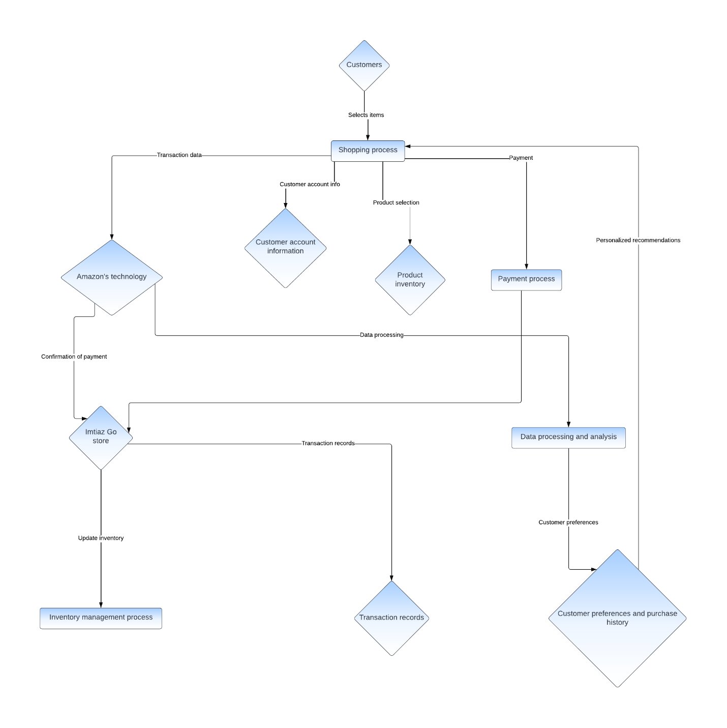

1. **Class Diagram:**

* A class diagram depicts the structure of the system by showing the classes, their attributes, methods, and relationships.
* The class diagram for Imtiaz Go illustrates the various entities such as customers, products, transactions, and the relationships between them.

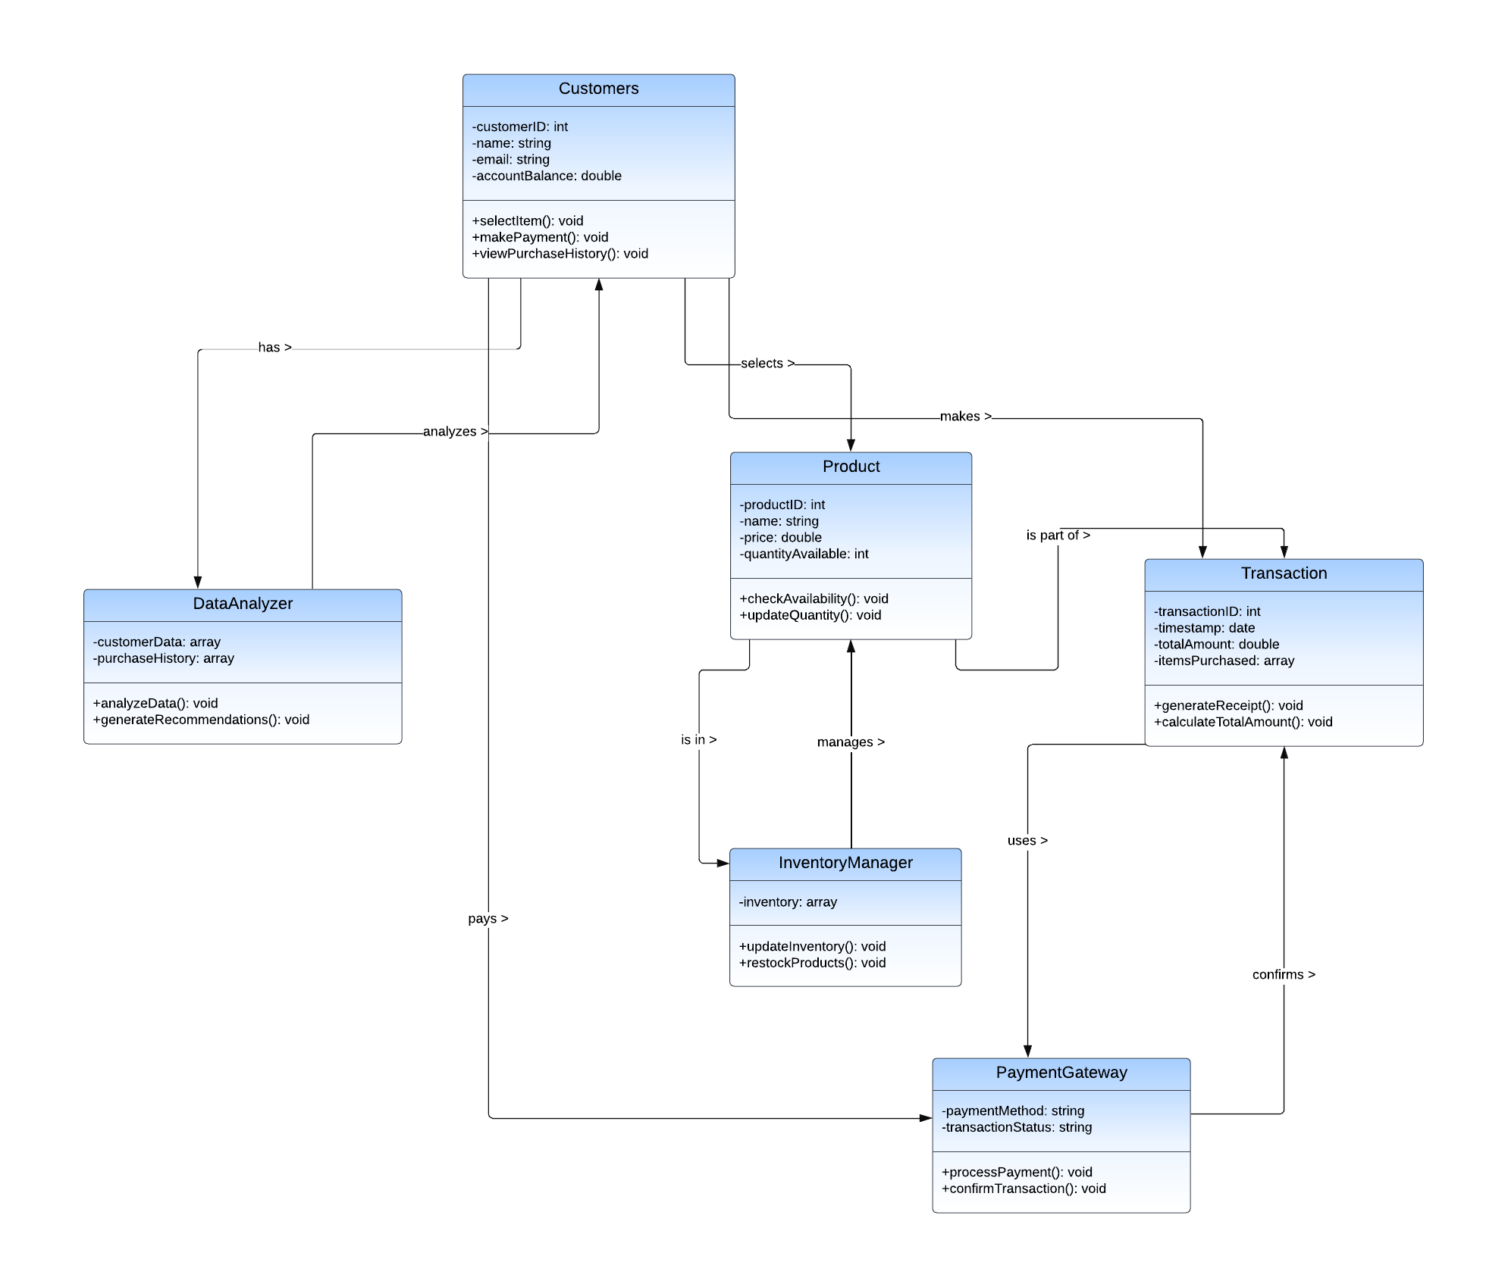

1. **State Transition Diagram:**

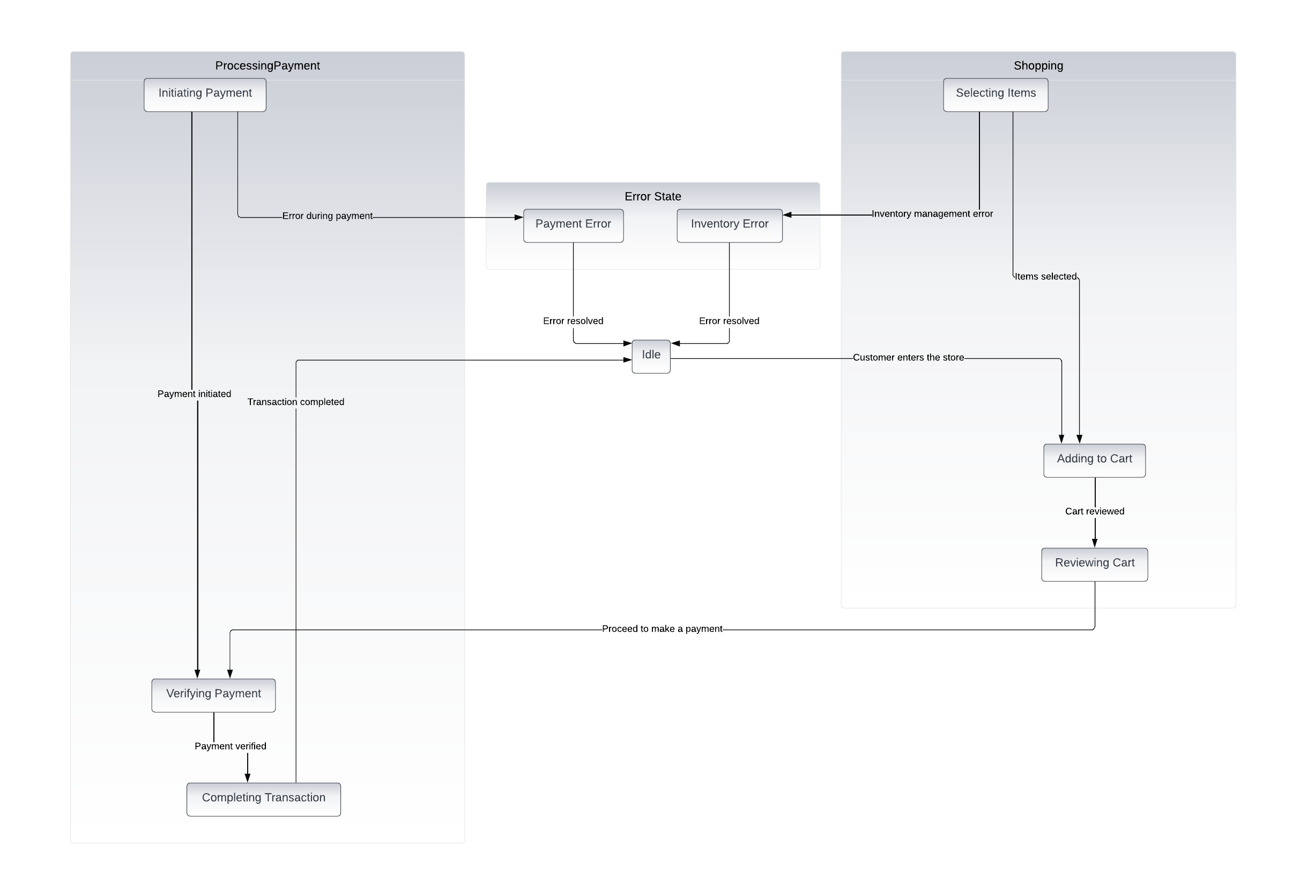

1. **Entity Relationship Diagram:**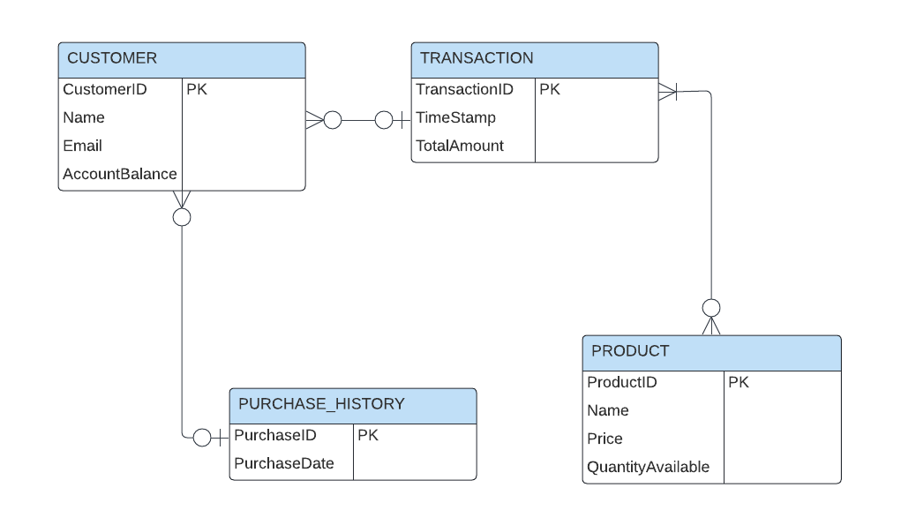

Appendix C: To Be Determined List

These TBD items require further investigation or clarification and will be addressed to ensure completeness and accuracy in the final SRS:

1. TBD: Specify performance requirements for peak usage scenarios.
2. TBD: Define specific communication protocols for hardware interfaces.
3. TBD: Determine the exact database requirements and data storage mechanisms.
4. TBD: Identify any additional security certifications required for the system.
5. TBD: Specify any legal requirements or regulations applicable to the software.
6. TBD: Determine the exact implementation constraints regarding software tools and technologies.
7. TBD: Define user authentication mechanisms for accessing the system.
8. TBD: Specify any internationalization requirements for the software.
9. TBD: Identify any reuse objectives for the project, including potential code reusability.
10. TBD: Determine the process for handling error conditions or invalid inputs.
11. TBD: Clarify any dependencies on external software components or libraries.
12. TBD: Specify any additional non-functional requirements related to usability and accessibility.
13. TBD: Identify the format and delivery mechanisms for user documentation.
14. TBD: Define the scope and content of system testing procedures.
15. TBD: Specify any constraints related to parallel operations or system scalability.